**Software Development Life Cycle (SDLC)**

**Software development life cycle (SDLC) is a structured process that is used to design, develop, and test good-quality software.** SDLC, or software development life cycle, is a methodology that defines the entire procedure of software development step-by-step

The goal of the SDLC life cycle model is to deliver high-quality, maintainable software that meets the user’s requirements. SDLC in software engineering models outlines the plan for each stage so that each stage of the software development model can perform its task efficiently to deliver the software at a low cost within a given time frame that meets users’ requirements.

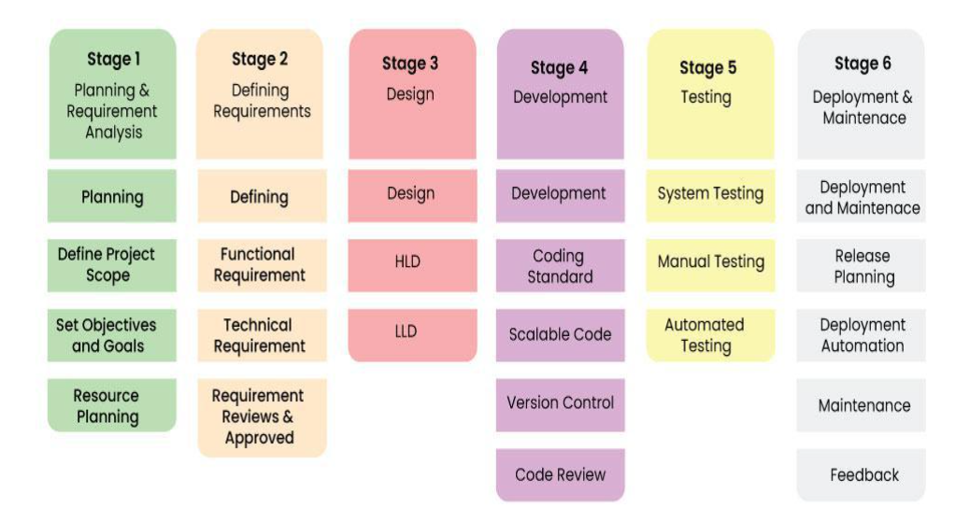

## [**Software Development Life Cycle Models**](https://www.geeksforgeeks.org/sdlc-models-types-phases-use/)

To this day, we have more than 50 recognized SDLC models in use. But None of them is perfect, and each brings its favourable aspects and disadvantages for a specific software development project or a team.

Waterfall Model

It is the fundamental model of the software development life cycle. This is a very simple model. The is not in practice anymore, but it is the basis for all other SDLC models. Because of its simple structure, the waterfall model is easier to use and provides a tangible output. In the waterfall model, once a phase seems to be completed, it cannot be changed, and due to this less flexible nature, the waterfall model is not in practice anymore.

Agile Model

The agile model was mainly designed to adapt to changing requests quickly. The main goal of the Agile is to facilitate quick project completion. The agile model refers to a group of development processes. These processes have some similar characteristics but also possess certain subtle differences among themselves.

Scrum Teams/Daily Calls(10-15 Mins) and Sprints are common for the Agile way.

Software Architecture – Design

* Micrservices and Microfrontends
* N – Tier Applications
* 3 Tier Application (<https://www.geeksforgeeks.org/three-tier-client-server-architecture-in-distributed-system/> )
* Client – Server Model

